c/o Touchstone, 32 Merton Rd, Bradford, BD7 1RE. 01274 721626
email: cofsbradford@gmail.com; www.cityofsanctuary.org/bradford

ANNUAL REVIEW

For the Period from 15.5.13 to 14.5.14

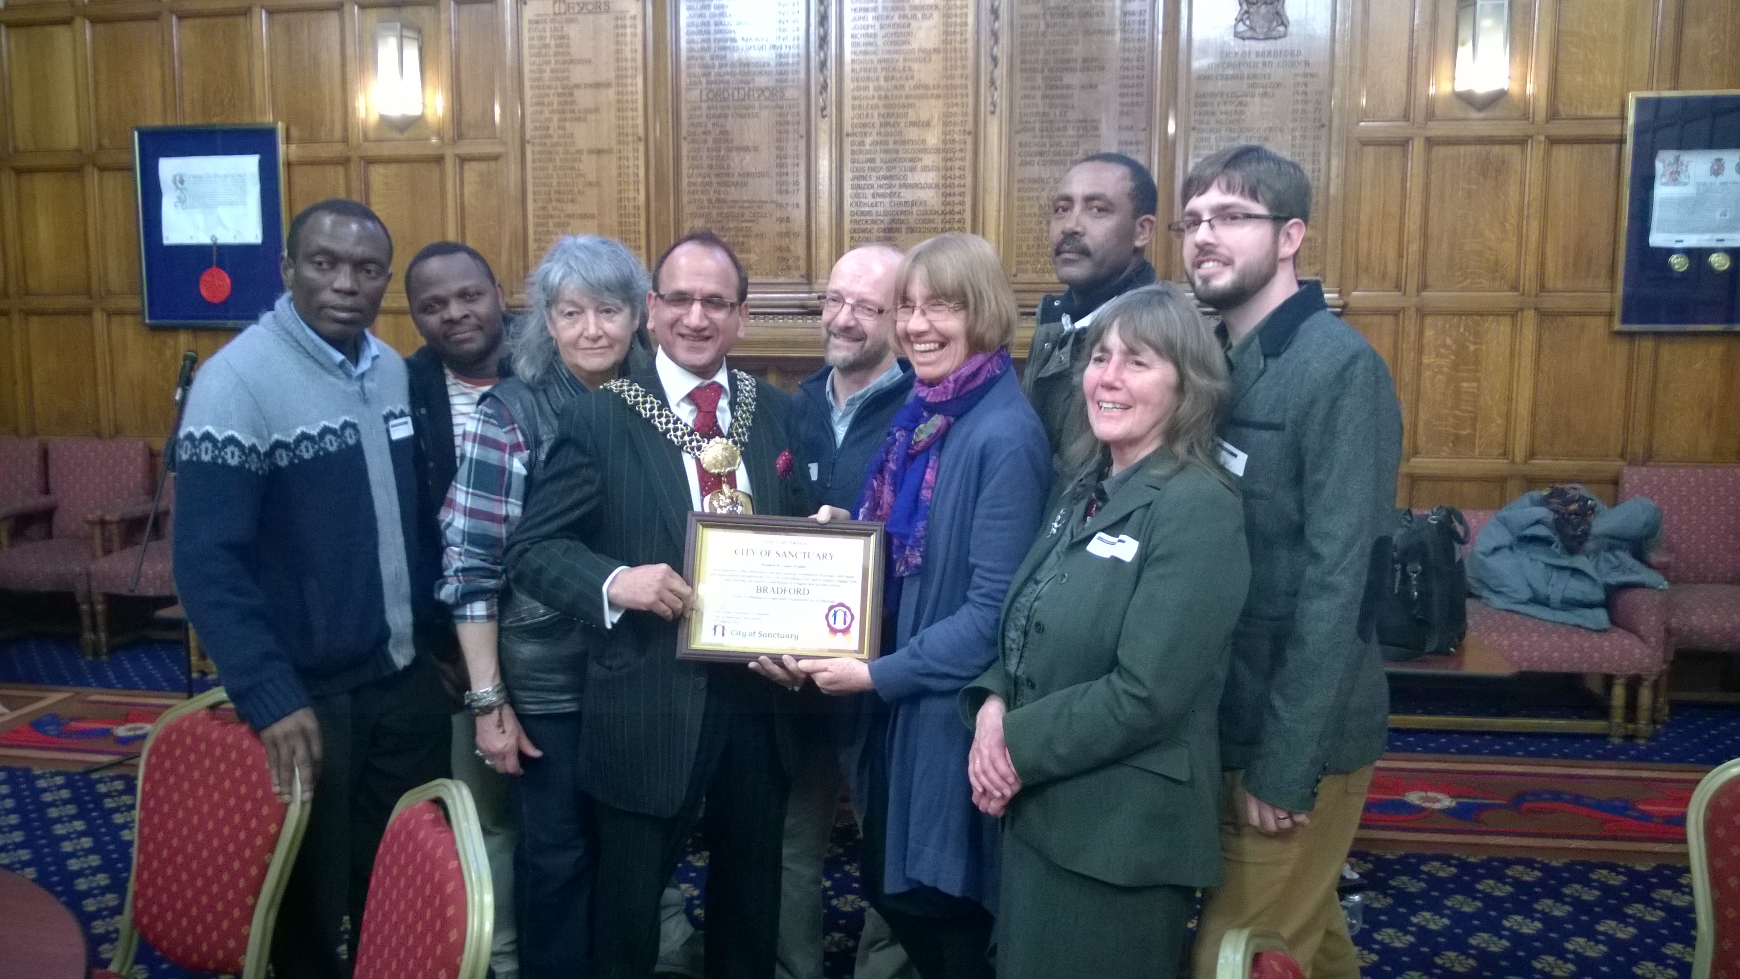

Renewal of ‘City of Sanctuary’ award 25th March

City of Sanctuary is a national movement to build a culture of hospitality for people seeking sanctuary in the UK. Its goal is to create a network of towns and cities throughout the UK which are proud to be places of safety, and which include people seeking sanctuary fully in the life of their communities. A ‘City of Sanctuary’ is a place where a broad range of local organisations, community groups and faith communities, as well as local government, are publicly committed to welcoming and including people seeking sanctuary.
Locally the campaign aims to challenge the negative stereotypes and sometimes deliberate misrepresentation of the issue of ‘asylum’ in the public domain. To achieve this, we seek to create opportunities for asylum seekers and refugees to be seen and heard within local communities. Our campaign is not just for ‘hearts and minds’ but aims to see asylum seekers and refugees able to participate much more widely in the life of the city, and for recognition of their gifts, abilities and culture.

RENEWAL OF RECOGNITION AS A ‘CITY OF SANCTUARY’ (see cover photo)
We were thrilled when Bradford’s application for renewal of its ‘City of Sanctuary’ (CoS) recognition was enthusiastically approved at the national CoS conference on 27th January. The process had included a review visit on 9th January by a small group representing the national trustees. A great deal of work went into our written submission which highlighted the huge range of initiatives across the city providing ‘welcome, hospitality and inclusion’ for those seeking sanctuary. It also included the findings of a number of individual questionnaires completed with sanctuary seekers, designed and carried out by Victoria Elahi. We were particularly grateful for support from Bevan House, BIASAN, Bradford Action for Refugees, Wellington Moyo (OUR Project) and Negussie Taye (Bradford Refugee Forum).
Following the award, a certificate was presented by Tiffy Allen (National CoS Coordinator) to Bradford’s Lord Mayor at a ceremony in front of the full Council on 25th March. Good media attention resulted, with three articles in the Telegraph & Argus, a BCB radio interview and also coverage in the new online paper The Yorkshire Standard.

SANCTUARY IN SCHOOLS (SIS) PROJECT
The Sanctuary in Schools project has now been running for twenty months and, after a slow start, is beginning to gain some momentum. SiS is a partnership project: the other partners are Bradford Action for Refugees/Northern Refugee Centre (www.bafr.org.uk) and the Zephaniah Trust (www.zephaniah.org.uk). In its second year the project is being funded by a grant from Bradford Two28 and by a generous personal donation. It was the intention to directly employ the Development Worker for twenty hours per week from September 2013. Because it proved impossible to raise the required funding, Mary Blacka is continuing to work for the project for fifteen hours per week on a self-employed basis.
At the time of writing the last Annual Review there were only two schools which had fully signed up to work towards the award of School of Sanctuary. There are now six schools – two secondaries and four primaries – working towards the award. We hope to make the first award of School of Sanctuary in Bradford to one of the primary schools in Refugee Week, June 2014.
SiS is organising a mixed-media exhibition in Refugee Week 2014. This will be open for a week, from 16-21 June 2014, in the Fabric Gallery in the city centre. It will showcase the work of SiS schools and of adult artists on the theme of “What is home?” There will also be a small exhibit about the child refugees from the Spanish Civil War who found sanctuary in the Bradford area in the 1930s and photographs of a recent visit to Hutton Roof by a group of asylum seekers and refugees. The exhibition will be accompanied by a programme of performances and activities in the day and evening, including storytelling, drama and family craft activities.
Mary has continued to work with other Schools of Sanctuary (SoS) colleagues and was part of the organising group for the first SoS conference in Leeds in October 2013. She has also co-delivered workshops at the regional CoS conference in Birmingham and at the national CoS conference in Leeds, both in January 2014.
Daryll Hackett has continued to provide Mary with support on behalf of BCoS. He has also chaired the SiS Steering Group, which includes representatives from all schools working towards the SoS award.
The funding climate remains very difficult. We are currently awaiting the outcome of three funding bids, to continue SiS's work into a third year. Our current plans to become a Charitable Incorporated Organisation will allow BCoS to access those funding bodies which only make grants to registered charities. Further funding bids will be made once registered status has been secured.

ACTIVITIES
Refugee Week. As in previous years we held displays at the Launch and Finale events. At the former, pupils from Salts College gave a very powerful performance of ‘Refugee Voices’.
Coleraine visit 20th June. We met with representatives from Coleraine who were interested in developing City of Sanctuary in Northern Ireland. The Causeway Borough of Sanctuary group developed very well in the weeks subsequent to the visit, and was formally launched and joined the CoS network in December.
Destitution Day of Action 29th June. This took place on 29th June, joining a number of other cities protesting on that day against the enforced destitution of refused asylum seekers. It was a success, with over 70 participating as well as support from a number of passers-by. Harry Femi took the lead with organising the event, which was reported in the Telegraph and Argus. A petition was signed by 200 people and submitted to the Council meeting on 9th July (see below).
Destitution Motion 9th July. Following the lead of groups in Glasgow, Bristol, Oxford and Sheffield, we worked closely with Destitution Concern Bradford to enable a motion to be put to Bradford Council, condemning the UK government’s policy of enforced destitution of refused asylum seekers. We were very grateful for support in this from Cllr Alex Ross-Shaw and absolutely delighted when the motion was passed with overwhelming cross-party support. Following the decision, the Council’s Chief Executive wrote to the then Immigration Minister outlining the above and calling for a change in policy to enable the Council to provide direct support to destitute asylum seekers. A reply has only just been received – after nine months!
Positive Bradford Day 28th Sept. We organised a ‘Sanctuary Tent’ for the third year running, enabling a number of local asylum organisations to hold displays. In addition, Lucy Dowling provided earring-making which was a great hit – in particular with children. We received some very positive feedback about our marquee, including one comment that it was the best of the day!
Away Day 27th July. Liz Firth very ably facilitated our second Away Day in the beautiful garden at the Bishop’s residence. A very successful day that helped us to identify and refine our priorities for the future.

OTHER INITITIATIVES
- Talks and Displays
  - Routes to Peace 26th June. At the event in Centenary Square children composed and sang peace songs and organisations including CofS manned displays.
  - Peace Fair 23rd November. As always, a very worthwhile event with a number of people signing up as supporters at our display.
  - For the return of the very moving and acclaimed Refugee Boy performances at West Yorkshire Playhouse in February, we again staged an all-day display. We were delighted when WYP received the UK’s first ‘Theatre of Sanctuary’ award at the national CoS conference in January.
  - We also had displays at the excellent first Sanctuary and Healthcare conference in September and a Why Refugee Women conference in March – both at Bradford University.
  - Will gave presentations to a number of groups during the year, including Court Chaplaincy volunteers’ training, Shipley Rotary Club, Ilkley Ecumenical Mothers’ Union, Shipley Baptist church as well as interviews on BCB Radio.
- Resolutions of Support. These now stand at a remarkable 163 organisations, groups, places of worship and businesses.
- Welcome to Bradford (W2B). In 2013 we catalysed the setting up of W2B which has now been adopted by the Hale Project in Shipley, giving it a much more secure base. W2B continues to provide a vital welcome and help with orientation to asylum seekers newly dispersed to the city.
- Access to Healthcare consultation. Teresa and Will compiled and returned a response on behalf of Bradford CoS to the Department of Health consultation on migrant access to health services.
- EDL demonstration 12th October. Will was enlisted as a ‘street calmer’ during the demonstration, while we displayed our banner at the Bradford Together event the day before. As with their previous unwelcome visit, the net lasting effect was positive in that many diverse groups and individuals came together in a united front to oppose racism, whilst the demonstration itself was poorly attended.
- National Involvement. Will was part of a small group that revised the procedures for ‘City (Town, Borough, etc) of Sanctuary’ recognition, and developed the ‘Streams of Sanctuary’ concept.
- Will continued to represent the group at the multi-agency New Arrivals Operations Group, coordinated by Bradford Council, which metamorphosed during the year to become the Asylum Seekers and Recent Refugees Operations Group.
- Website (http://www.cityofsanctuary.org/bradford) and Facebook. Both sites would benefit from someone with time to maintain them – something we hope to rectify with the appointment of a Development Worker in the coming months.
In addition to all the above, we are involved in daily networking, information-sharing and resourcing other organisations and individuals. We see putting people together as one of the key benefits of what we do.

FUNDING
As noted above, we are indebted to Two28 and Near Neighbours for enabling the initial development of our Sanctuary in Schools project and to Two28 and an extraordinarily generous individual donor for the current year (from September 2013). In addition we received generous gifts from Bradford City Centre Project, St Clements church, Shipley Rotary Club and a regular donor.
We continue to be very grateful to Touchstone Methodist Centre for their invaluable goodwill and support-in-kind.
COMMITTEE

The Committee over the past year has been:

- Chair: Will Sutcliffe
- Vice Chair: Helen Kemp
- Treasurer: Ian McIver
- Secretary: Linda White (resigned during year due to ill health)
- Joe Batt, Christy Bischoff, Victoria Elahi, Teresa Jack

A number of others have regularly attended our monthly meetings and made very significant contributions to our work.

Will Sutcliffe – Chair
April 2014

City of Sanctuary Bradford
Accounts for the year ending 31 March 2014

Incoming Resources |  |  |  | General Fund
 | Grants | £2,916.69 |  | Opening Balance |  | £1,578.06
 | Donations | £1,106.00 |  | In |  | £1,112.36
 | Summer School income | £11,140.00 |  | Out |  | £621.60
 | Interest | £6.36 |  | BALANCE |  | £2,068.82
Total Incoming Resources |  | £15,169.05
 |  |  |  | Schools Work
Resources Expended |  |  |  | Opening Balance |  | £5,971.60
 | Travel | £79.70 |  | In |  | £14,056.69
 | Wages | £9,608.36 |  | Out | Wages | £9,608.36
 |  |  |  |  | Summer School | £6,040
 | Stationary | £0.00 |  |  | Expenses | £89.32
 | Postage | £0.00 |  | BALANCE |  | £4,290.61
 | Summer School expenditure | £6,040.00
 | Misc | £15.62
 | Phone | £40.00
 | Charges | £0.00
 | Publicity | £47.60 |  | TOTAL BALANCE |  | £6,359.43
 | Insurance | £238.50
 | Accommodation | £271.50 |  | CREDITORS |  | £0.00
 | Events | £18.00 |  | DEBTORS |  | £0.00
Total Resources Expended |  | £16,359.28

